**What is VBA**

VBA stands for Visual Basic for Applications. It helps to record routine tasks. In other words, it is possible to use VBA to create Macros. Usurer can record Macros with a Macro recorder. The Macro recorder is simple and easier to use. It allows performing direct tasks, but not complicated tasks. Therefore, we can use VBA to expand the usual functionalities and to create advanced programs.

**How to Create a Macro using VBA**

You can create a Macro using VBA by following the below steps.

If there is no develop tab in Excel, the user can right click anywhere in the ribbon.

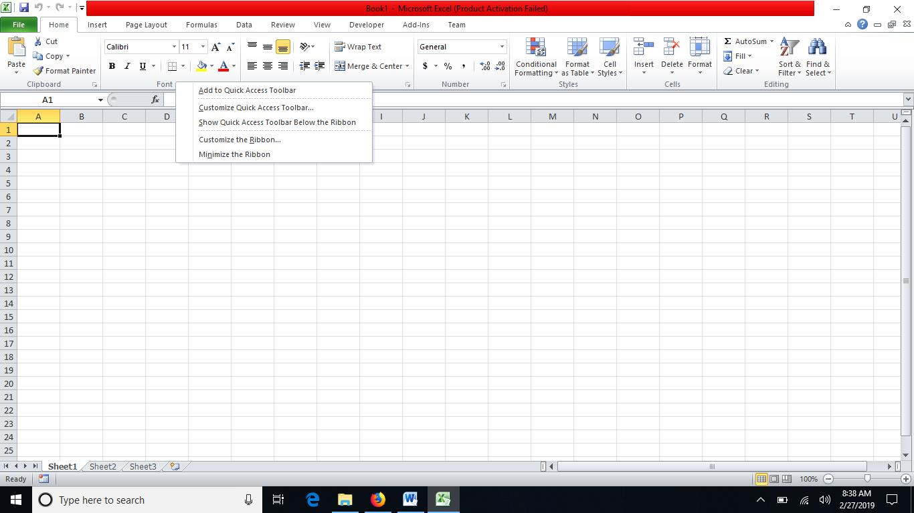

Then, he can select customize the ribbon option. It will open a dialog box. Then, the user can select the developer option and click ok.

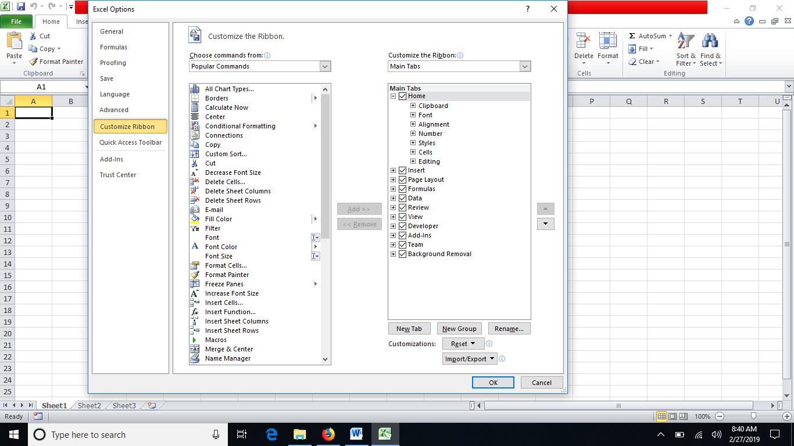

Now the developer tab is added to the ribbon.

Next, go to the developer tab and select Insert.

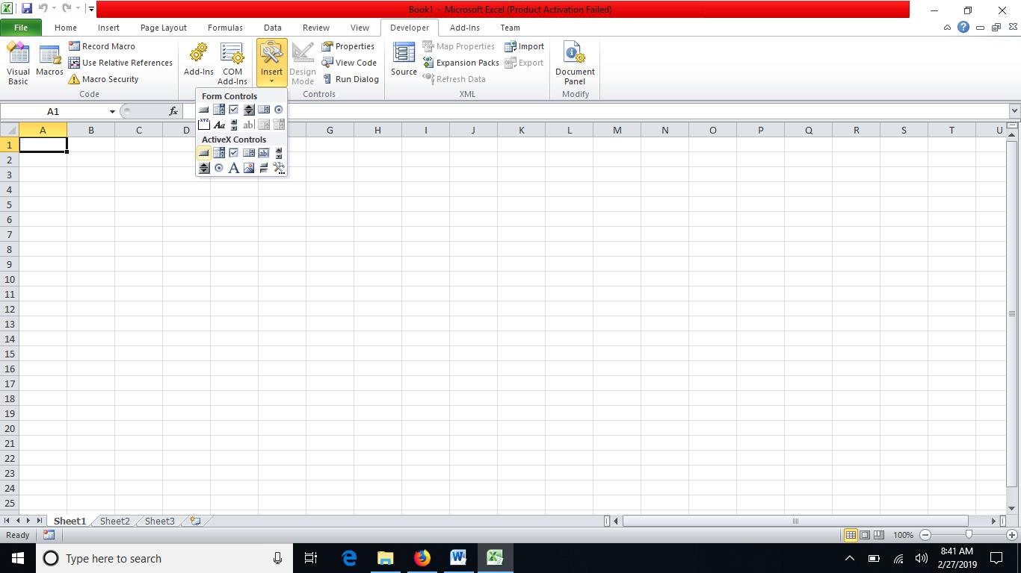

Click the Command button from ActiveX Controls group.

Now the cursor changes into a plus sign. The user can draw the button on the sheet.

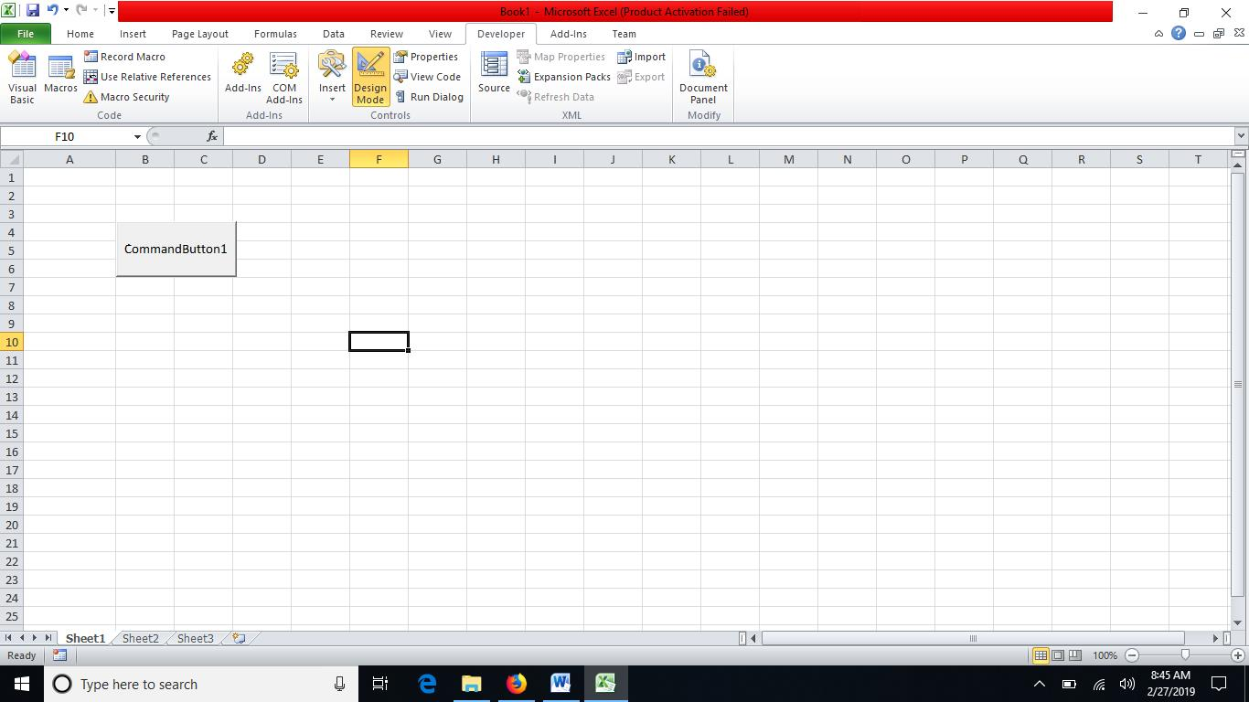

Now he can right-click on that button and select the view code option.

It will open the Microsoft Visual Basic for Applications window.

Now, the user can enter the code for Command Button1.

Then, the user can close the Microsoft Visual Basic for Applications window.

He can deselect the design mode.

Click on the command button1. It will print “Hello World” on A1 cell as follows.

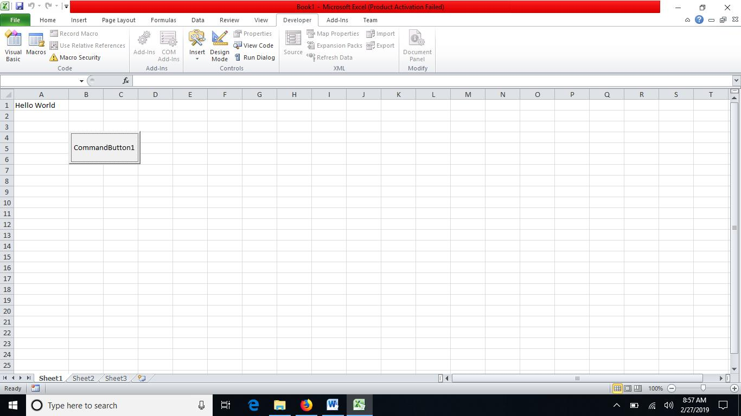

So, this is the method of creating a macro using VBA in excel.

Excel was the first Microsoft application to use VBA. Furthermore, users can also press Alt and F1 keys together to open the Microsoft Visual Basic for Applications window.

**What is Macro**

Macro is a collection of commands that runs on an Excel environment. It can execute that command with a single click. Macros help to automate routine tasks. In other words, a Macro is a computer program that provides automated instructions to the computer. Therefore, the user can execute the same tasks again and again. Moreover, it can be recorded and replayed from a specific entry point. Therefore, it is possible to repeat the macro multiple times as required by replaying the macro.

**How to Create a Macro using Macro Recorder**

Users can go to the left bottom of the excel page. There is a ready tag. Right-click on that bar to the right of “ready”.

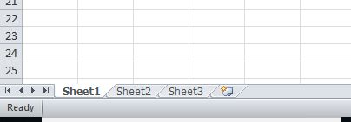

A list of options appears on the screen. Now the user can select “Marco Recording”.

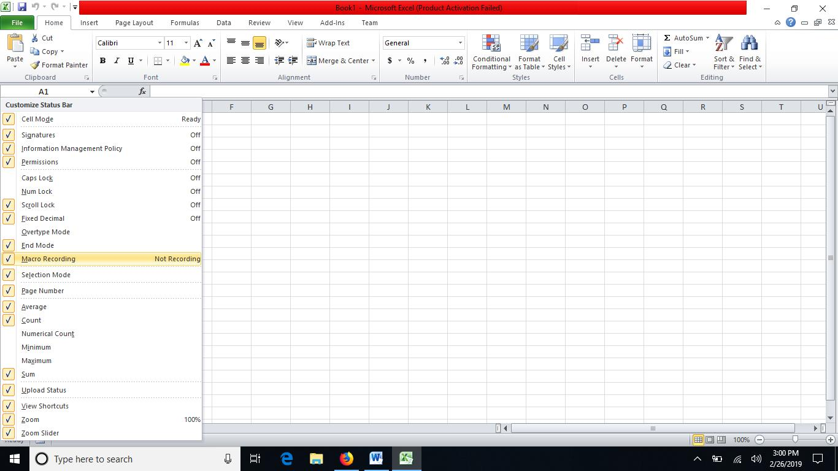

Now, the user can see the Macro button as shown below.

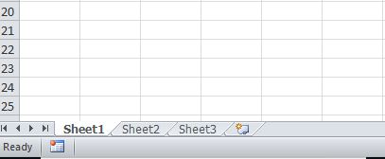

Clicking on that icon opens the Record Macro window.  User can give a name to the Macro and press ok.

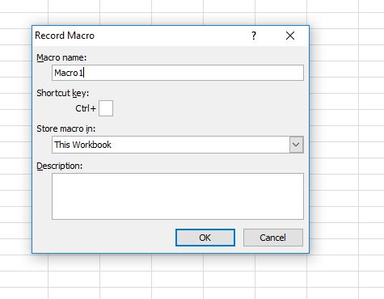

Now the macro is recording.

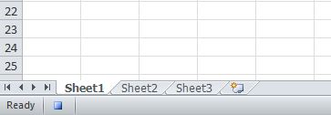

After completing the task, the user can go below the Excel sheet and click on the Macro button to stop recording the macro.

**Relationship Between VBA and Macros**

* It is possible to create Macros using VBA.

**Difference Between VBA and Macros**

**Definition**

VBA is a programming language for developing automated tasks for Excel and other Microsoft Office programs like Word and PowerPoint while macros is a collection of commands that is used to replace a repetitive series of keyboard and mouse actions in an application such as MS Excel. Thus, this explains the main difference between VBA and Macros.

**Basis**

VBA is a programming language while Macro is a set of commands of a programming code that can be repeated multiple times.

**Conclusion**

There is a distinct difference between VBA and Macros although some people use these two terms interchangeably. The main difference between VBA and Macros is that VBA is the programming language to create Macros while Macros are programming codes that run on Excel environment to perform automatic routine tasks.